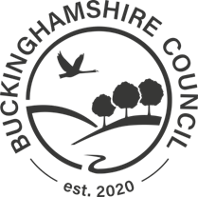  The Occupier  High Street  Edlesborough | Directorate for Planning Growth & Sustainability  Buckinghamshire Council,  Walton Street Offices,  Walton Street,  Aylesbury  HP20 1UA  Date: 11th July 2023

Proposed Build-out – High Street, Edlesborough

Notice is hereby given pursuant to Section 90 of the Highways Act 1980 The Highways (Traffic Calming) Regulations 1999 and all other enabling powers, that Buckinghamshire Council in conjunction with Jarvis Homes Ltd are undertaking a consultation for the introduction of a build-out on High Street, Edlesborough in connection with planning application APP/J0405/W/21/3281241.

The build-out will be constructed and funded by Jarvis Homes Ltd.

These works will be carried out utilising the existing Section 278 Highway Works Agreement. We enclose a copy of the site notice and plan.

The Council will notify the appropriate Chief Officer of Thames Valley Police of this intention.

This consultation will run from 11th July until 18th August 2023 and you can respond via our “Your Voice Bucks” web site on the link below, email to highwaysdm@buckinghamshire.gov.uk or write to Highways Development Management, Floor 6, Walton Street Offices, Walton Street, Aylesbury, HP20 1UA.

https://yourvoicebucks.citizenspace.com

Yours Faithfully,

Highways Development Management
Directorate for Planning Growth & Sustainability
Buckinghamshire Council

