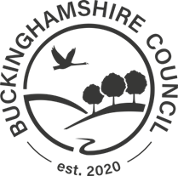 | Directorate for Planning Growth & Sustainability  Buckinghamshire Council,  Walton Street Offices,  Walton Street,  Aylesbury  HP20 1UA

BUCKINGHAMSHIRE COUNCIL

PROPOSED BUILD-OUT

High Street, Edlesborough

NOTICE IS HEREBY GIVEN that Buckinghamshire Council, in exercise of its powers under Section 90 of the Highways Act 1980, The Highways (Traffic Calming) Regulations 1999 and all other enabling powers in conjunction with the developer Jarvis Homes Ltd proposes to construct a build-out in the publicly maintained section of High Street, Edlesborough.

The build-out in the publicly maintained highway is to be constructed (17.5m in length) at the following location:

- At a point approx. 22 metres North of the junction of High Street and Good Intent.

A copy of the plan showing the road to be affected and the location of the Road Hump may be inspected by appointment during normal office hours at Walton Street Offices, Aylesbury.

Objections to the proposal together with the grounds on which they are made must be sent in writing to the undersigned (for the attention of Mr J. Bates) by 18th August 2023, emailed to highwaysdm@buckinghamshire.gov.uk or submitted via our “Your Voice Bucks” website at
https://yourvoicebucks.citizenspace.com.

Dated 11th July 2023

S. BAMBRICK
PLANNING & ENVIRONMENT SERVICE DIRECTOR
WALTON STREET OFFICES, WALTON STREET, AYLESBURY, HP20 1UA

