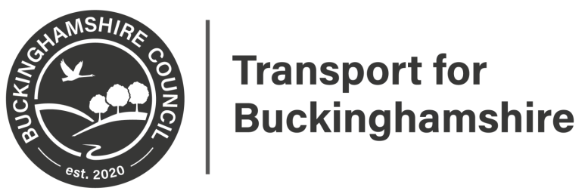

Statutory Consultation
A355 Amersham Road Proposed Speed Limit Reduction
This may affect you.

Please scan for further information

Closing date 29th October 2021

Please provide feedback at:
https://yourvoicebucks.citizenspace.com/
01296 382416

