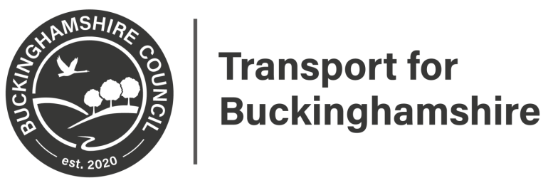

Statutory Consultation
A40 Oxford Road/Wycombe Road Proposed Speed Limit Reduction
This may affect you.

Please scan for further information

Closing date 13th August 2021

Please provide feedback at:
https://yourvoicebucks.citizenspace.com/
01296 382416

