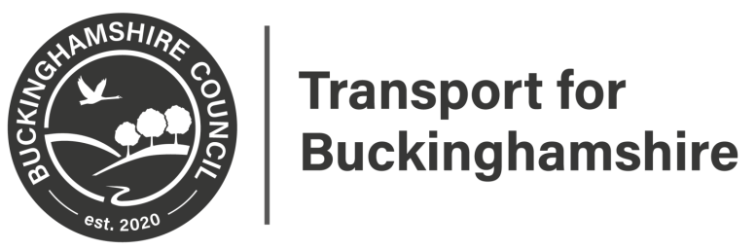

Statutory Consultation
A413 Amersham Road Movement
Bans
This may affect you.

Please scan for further information
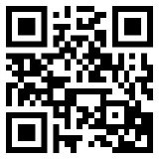

Closing date 26th October 2021

Please provide feedback at:
https://yourvoicebucks.citizenspace.com/
01296 382416

