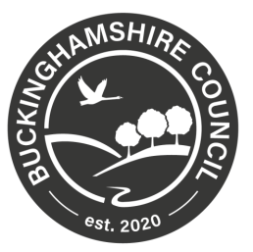

Buckinghamshire Council
The Buckinghamshire Council (Speed Limit) Order 2021
(Amendment No 000*) Order 202*

The Buckinghamshire Council (hereinafter referred to as “the Council”) in exercise of its powers under sections 82, 83 and 84 and part IV of schedule 9 to the Road Traffic Regulation Act 1984 (“the Act”) and of all other enabling powers, and after consultation with the Chief Officer of the Police in accordance with Part III of Schedule 9 to the Act, hereby makes the following Order.
- The Buckinghamshire Council (Speed Limit) Order 2021 (Amendment No 00*) Order 202* and shall come into operation on ** *** 202*.
- As from the date upon which this Order comes into operation, the provisions of The Buckinghamshire Council (Speed Limit) Order 2021 shall be varied as follows:

- to update schedule.
Schedule 2 BC-2021/SPEED/00* | is replaced by | Schedule 2 BC-2021/SPEED/00*

- to amend map tiles as follows:
Area Code: BN38 | Revision Number | 0 | is replaced by | Revision Number | 0
Area Code: BO38 | Revision Number | 0 | is replaced by | Revision Number | 0
Area Code: BO39 | Revision Number | 0 | is replaced by | Revision Number | 0

The common seal of
BUCKINGHAMSHIRE COUNTY
was hereunto affixed this ** day of ***
Two thousand and ** in the presence of:

Authorized Signatory

