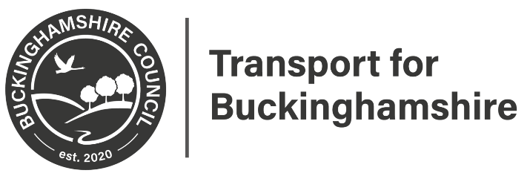
Directorate for Communities
Contract Director: Andrew Sellors
Design Services
Transport for Buckinghamshire
Aylesbury Vale Area Office
Corrib Industrial Park, Griffin Lane
Aylesbury
HP19 8BP
01296 387496
www.buckinghamshire.gov.uk

December 2022

Dear Sir or Madam

A413 Buckingham Road, Winslow 30mph speed limit extension - Formal Consultation

We are working with your Parish/Town Council and Community Board to draw up draft proposals for speed review on A413, Buckingham Road. The aim of the review is to improve safety on the edge of the town.

At this ‘Formal consultation’ (legal) stage we are putting forward the proposal of extending the 30mph speed limit near the junction with Furze Lane, Winslow
We invite residents and other interested parties to let us have your views on the proposals. No decision has been made at this point.
What can you do?

If you would like to comment on the proposals or view the plan, please visit an online survey https://yourvoicebucks.citizenspace.com/roads-parking/a413-speed-limit-formal-consultation, or use the QR code below, where you can submit your responses to have your say.
Please complete the survey by midnight Friday 13th January 2023.

QR Code:

Alternatively, you can email us at: parkingtro@buckinghamshire.gov.uk or write to us at the address at the top of this letter with your comments. If you do not have access to the internet, you can find a copy of this letter and copies of all the plans at Buckinghamshire Council, Council Access Plus, Walton Street Offices, Walton Street, Aylesbury, HP20 1UA.

We have to make any representations received in response to this letter open to public inspection, however, we will remove personal information such as your name or address.

What happens next?

Once the Formal consultation has finished, all responses will be considered, and the plan will be amended accordingly (if necessary). We will then formally advertise the making of the Amendment Order, based on the outcome of the Formal Consultation. All going well we hope to implement the lines in summer 2023. This web page www.yourvoicebucks.citizenspace.com/ will keep you updated about the outcome of the x

Yours faithfully

Ujjwal Kakkar
Design Services, Graduate Engineer, Transport for Buckinghamshire
01296 387496

