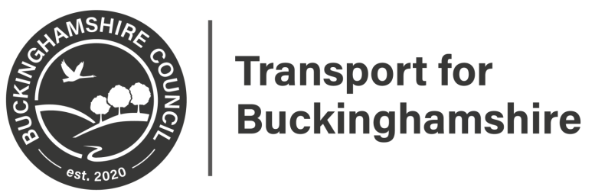

Statutory Consultation
Amersham Parking Review 2020
This may affect you.

Amersham, Chesham Bois and Penn Parking Restrictions Survey

Please scan for further information
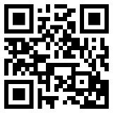

Closing date 17th July 2020

Please provide feedback at:
https://yourvoicebucks.citizenspace.com/
01296 382416

