Buckinghamshire Council
(Temporary Traffic Restrictions)
Country Parks - 24 Hour Clearway &
No Stopping At Any Time on Verge or Footway
Notice July 2020
Notice is hereby given that Buckinghamshire Council in pursuance of the provisions of the Road Traffic Regulations Act 1984, Section 14(1), as amended.
The Order shall come into operation on the 13th day of July 2020 and shall remain in force for eighteen months.
This Order shall come into operation from 0001 hours on 13th day of July 2020 to 2359 on the 12th day of Jan 2022.
Nothing in this Order shall apply to:
- Any vehicle being used for police, fire brigade or ambulance purposes.
- Anything done with the permission or at the direction of a police officer in uniform or a Civil Enforcement Officer or a Police Community Support officer.
The effect of which will be to introduce:
24-hour rural clearway restrictions at the following locations:-

- Rowley Lane (Wexham) – From its junction with Black Park Road north westerly direction for 460m on both sides of the highway.
- Black Park Road (Fulmer/Iver) – Full length both sides.
- Fulmer Common Road (Fulmer) – From its junction with Black Park Road easterly to it junction with Pinewood Road/Alderbourne Lane, on both sides.
- Pinewood Road (Iver) - From its junction with Alderbourne Lane to its junction with Seven Hills Road on both sides.
- Alderbourne Lane (Fulmer) – From its junction with Pinewood Road/Fulmer Common Road in a northerly direction for 20m.
- Billet Lane (Iver) – From its junction with Bellswood Lane 26m north of the junction and 507m south of the junction on both sides.
- Bellswood Lane (Iver) – From its junction with Billet Lane eastwards for 170m on both sides.
- Brickhill Road (Leighton Buzzard) – From a point 728m North West from its junction with the Woburn Road northward for 960m (both sides).
No Stopping At Any Time on Verge or Footway restrictions at the following locations:-

- Denham Court Drive (Denham) – From its junction with the A40 northwards for 834m to the entrance of Buckinghamshire Golf Club.
- Rowley Lane (Wexham) – From its junction with Black Park Road north westerly direction for 460m on both sides of the highway.
- Black Park Road (Fulmer/Iver) – Full length both sides.
- Fulmer Common Road (Fulmer) – North Side from its junction with Black Park Road easterly to it junction with Pinewood Road/Alderbourne Lane.
- Fulmer Common Road (Fulmer) – South Side from its junction with Black Park Road to a point 313m east of that point.
- Fulmer Common Road (Fulmer) – South Side from a point 357m east of its junction with Black Park Road to a point 37m east of that point.
- Fulmer Common Road (Fulmer) – South Side from a point 425m east of its junction with Black Park Road to a point 25m east of that point.
- Fulmer Common Road (Fulmer) – South Side from a point 470m east of its junction with Black Park Road to a point 125m east of that point.
- Fulmer Common Road (Fulmer) – South Side from a point 637m east of its junction with Black Park Road to a point 47m east of that point.
- Fulmer Common Road (Fulmer) – South Side from a point 712m east of its junction with Black Park Road to a point 206m east of that point to it junction with Pinewood Road/Alderbourne Lane.
- Pinewood Road (Iver) - From its junction with Alderbourne Lane to its junction with Seven Hills Road on both sides.
- Alderbourne Lane (Fulmer) – from its junction with Pinewood Road/Fulmer Common Road in a northerly direction for 20m.
- Billet Lane (Iver) – From its junction with Uxbridge Road (A412) southward to a point 507m south of the junction with Bellswood Lane, on both sides.
- Bellswood Lane (Iver) – From its junction with Billet Lane eastwards for 170m on both sides.
- Brickhill Road (Leighton Buzzard) – From a point 728m North West from its junction with the Woburn Road northward for 960m (both sides).
- Upper Icknield Way (Pitstone) – On its south east side from its junction with Northfield Road in a north easterly direction for 280m.
- Upper Icknield Way (Pitstone) – On its north east side from its junction with Westerly Road in a north easterly direction for 70m.
- Upper Icknield Way (Pitstone) – On its south west side from its junction with Northfield Road in a south westerly direction for 50m.
- Upper Icknield Way (Pitstone) – On its North West side from its junction with Westfield Road in a south westerly direction for 55m.
- Northfield Road (Pitstone) – On its north east side from its junction with Upper Icknield Way in a south east direction for 20m.
- Northfield Road (Pitstone) – On its south east side from its junction with Upper Icknield Way in a south east direction for 20m.
- Westfield Road (Pitstone) – On its east side from its junction with Upper Icknield Way in a northerly direction for 110m.
- Westfield Road (Pitstone) – On its west side from its junction with Upper Icknield Way in a northerly direction for 110m.

Christopher Anousis
Acting Client Contract Manager (Operations)
Authorised Signatory

Dated: 13th July 2020

24-hour rural clearway (marked in red), verge parking ban (marked in green) and parking bays (marked in blue).

Rowley Lane - Wexham
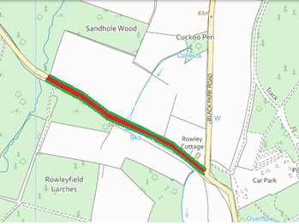

Fulmer Common Road - Fulmer
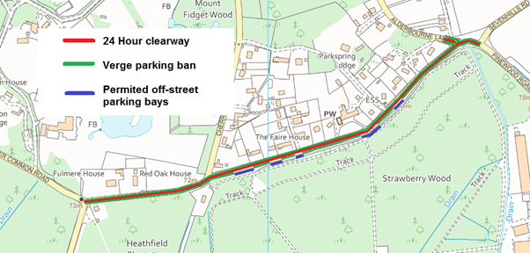

Black Park Road - Wexham
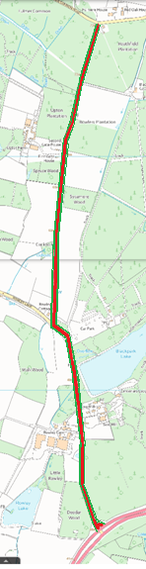

Billet Lane and Bellswood Lane - Iver
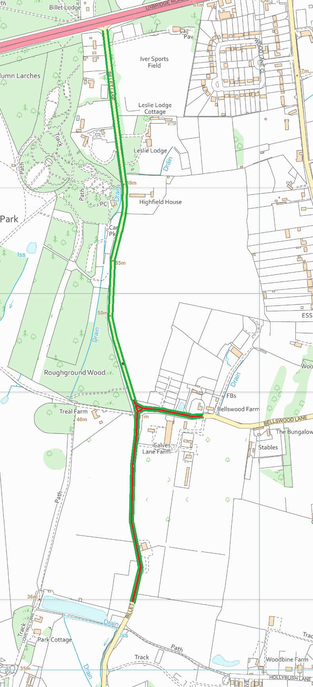
Denham Court Drive - Denham
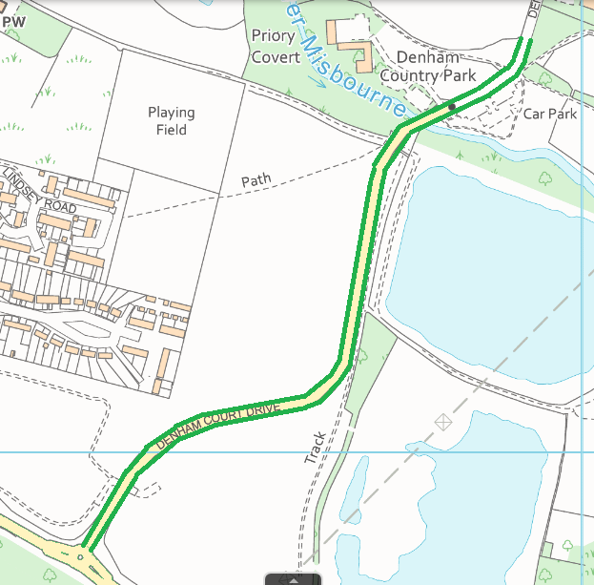

Brickhill Road - Leighton Buzzard
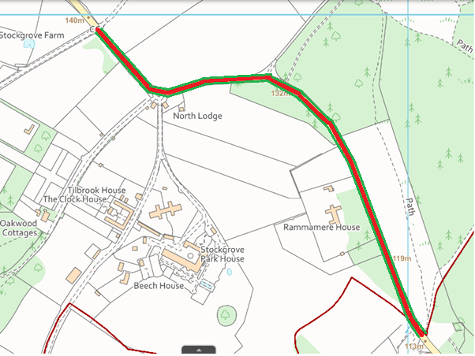

Upper Icknield Way junction with Northfield Road and Westfield Road - Pitstone
