Buckinghamshire Council
(Temporary Traffic Restrictions)
Haddenham Active Travel Plan pop up cycle way
Notice Sept 2020
Notice is hereby given that Buckinghamshire Council in pursuance of the provisions of the Road Traffic Regulations Act 1984, Section 14(1), as amended.
The Order shall come into operation on the ** day of September 2020 and shall remain in force for 18 months with a review after a 3 month period.
This Order shall come into operation from 0001 hours on 7th day of Sep 2020 to 2359 on the ** day of March 2021 with a review on the ** December 2020.
Nothing in this Order shall apply to:
a) Any vehicle being used for police, fire brigade or ambulance purposes.
b) Anything done with the permission or at the direction of a police officer in uniform
or a Civil Enforcement Officer or a Police Community Support officer.
The effect of which will be to introduce:

The introduction of “No waiting at any time” restrictions at the following locations: -
Thame Road (Haddenham)
- From at point 160m from the railway station roundabout leading to Thame Road in a northeast direction for 35m on the northern side.
- From at point 22m from the junction of Thame Road and Yolsum Close in a northeast direction for 32m on the northern side.
Tacks Lane (Haddenham)
- Full length on the northern side.
Bank Road (Haddenham)
- From its junction with Tacks Lane for 160m on the northern side.
See maps attached.

Rob Smith
Service Director - Highways and Technical Services
Authorised Signatory

Dated:

Double yellow line parking restriction sections are marked in yellow:

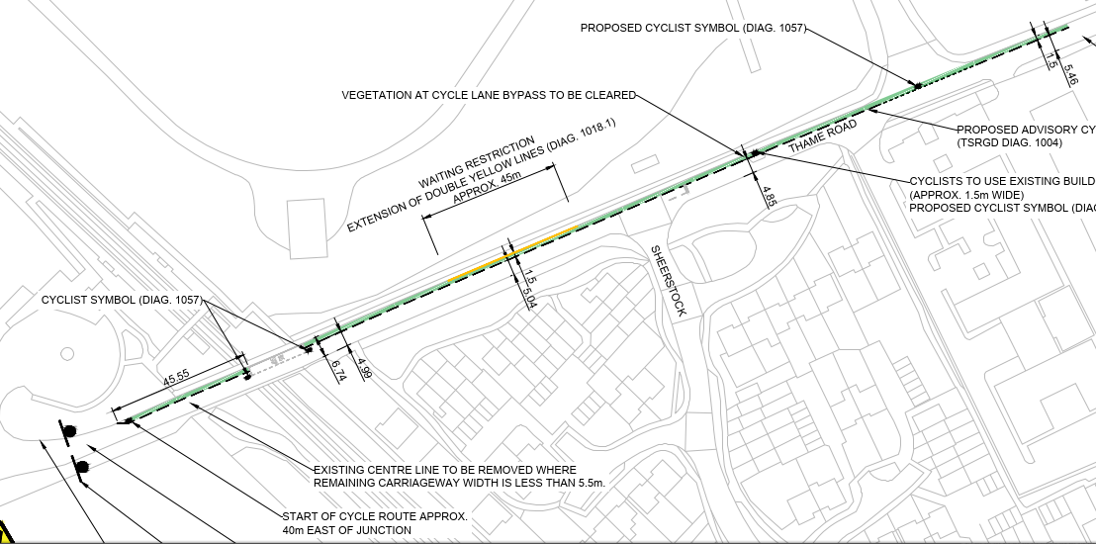

Fig 01 - Thame Rd – Haddenham section No.1

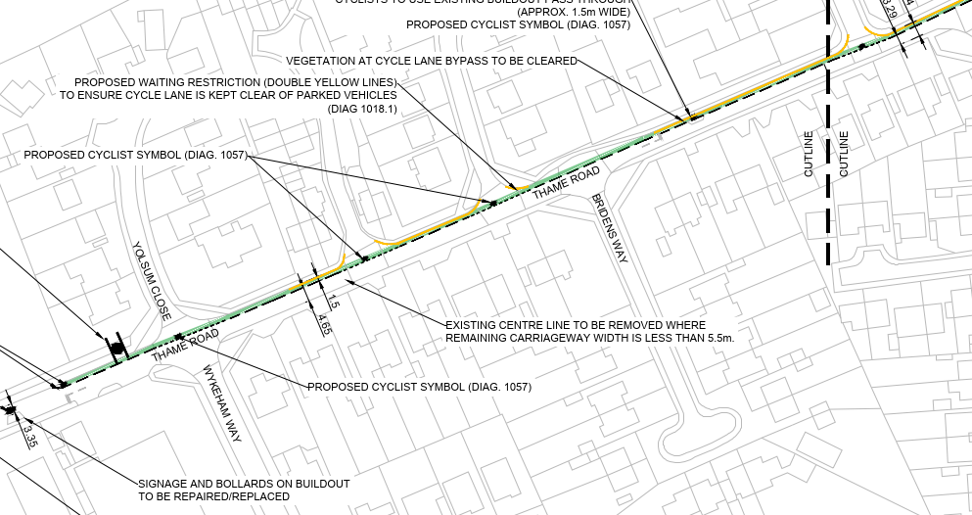

Fig 02 - Thame Rd – Haddenham Section no.2 & 3

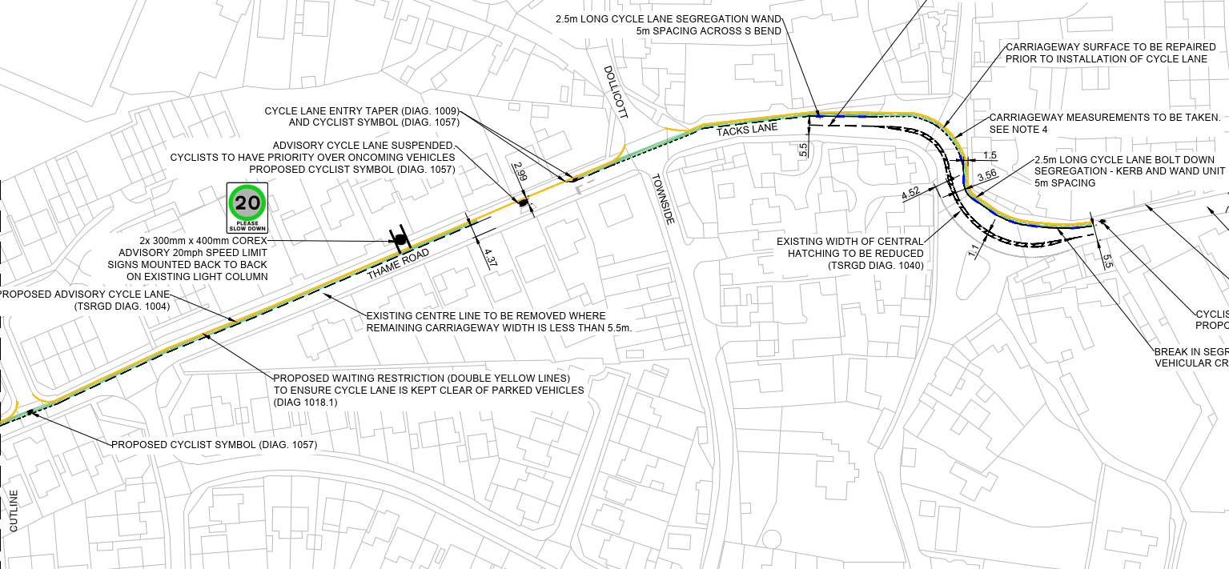

Fig 03 - Thame Rd – Haddenham section No.4

