Date: 25 November 2022

Ref: HFR Traffic Calming

Dear Sir / Madam

Proposed Speed Cushions on Hicks Farm Rise

This letter is to let you know that we are undertaking a consultation on the permanent introduction of speed cushions along Hicks Farm Rise (High Wycombe) to reduce traffic speeds, which has generated much public concern, and improve safety for all motorists and local residents.

The works will include erecting new advancing warning signs and installing new pairs of speed cushions. There will also be street lighting improvements to adequately illuminate the installed speed cushions.

High Wycombe Community Board has secured funding for the full implementation of the scheme. All future maintenance costs will be the responsibility of Buckinghamshire Council.

The consultation is anticipated to have a three week duration, and expected to run from Friday 25 November to Monday 19 December 2022. Subject to a successful outcome, it is the intention for Transport for Buckinghamshire (TfB) to construct and deliver the scheme during Winter / Spring 2023.
Transport for Buckinghamshire is seeking your views regarding the proposed scheme. Please find enclosed a drawings, which shows the location and details of the scheme; Indicative cushion positions are shown on the attached plans as Sheets 1 to 3. The position of the cushions are restricted by the numerous private vehicle accesses off Hicks Farm Rise.

What can you do?

Support or objections to the proposal, together with the grounds on which those objections are being made, must be sent
In writing to: Design Services, Transport for Buckinghamshire, Aylesbury Vale Area Office, Corrib Industrial Park, Griffin Lane, Aylesbury, Bucks, HP19 8BP
By email to: tfbschemesdelivery@buckinghamshire.gov.uk
By telephone to: 01296 382416 (BC Contact Centre)
Any comments should be sent by email or to the address above, by 19th December 2022.
A copy of the plan may be inspected during opening hours at Buckinghamshire Council | Council Access Plus | Walton Street Offices | Walton Street | Aylesbury | HP20 1UA.

Digital copies of the consultation documents will be on the Council’s Your Voice Bucks webpage: http://yourvoicebucks.citizenspace.com

What happens next?

Once the consultation results are collated and analysed, its results and recommendations will be submitted to the local members / Councillors. Subject to feedback received, a Key Decision Report (KDR) may be required to determine the next steps.

Any objections to this proposal will then be reported to the Cabinet Member for Transport, who will consider them along with other supporting information and decide whether the scheme can be approved for implementation. This report will also be available on the Buckinghamshire Council’s webpage.

Thank you for taking the time to read this letter! If you have any further questions about these proposed changes or require assistance to take part, please call our contact centre on 0845 2302882 / 01296 382416.

Yours faithfully,

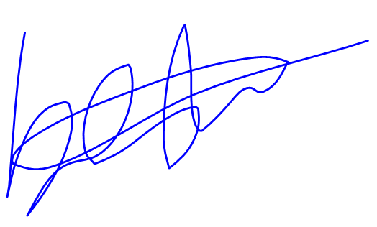

Bestman Agu
Design Engineer
Transport for Buckinghamshire
Corrib Industrial Park, Griffin Lane, Aylesbury, Buckinghamshire HP19 8BP

