REF: High Wycombe Parking Review 2023 – Area 2
Dear Resident,

Proposals to introduce Parking Restrictions in High Wycombe

We are reviewing the parking controls located close to your property and would like to hear your views.

No decision has been made at this point, further details regarding the proposals can be found overleaf.

What can you do?

If you would like to comment on the proposals, please visit the Your Voice Bucks website at https://yourvoicebucks.citizenspace.com/ and look for “High Wycombe Parking Review – Informal Consultation” where you will find a link to an online survey.

Alternatively, you can email us at: parkingtro@buckinghamshire.gov.uk or write to us at the address Buckinghamshire Council, Walton Street Offices, Walton St, Aylesbury, HP20 1UA with your comments.

The consultation will close on Monday 18th September 2023.

We are required to leave any comments open to public inspection, however we will remove personal information such as your name or address.

What happens next?

We will develop the parking proposals based on what residents and businesses within the area tell us. If feedback shows people want to change the existing parking controls, we will begin the legal process of changing the parking controls and we will write to you again to seek your views.

If we do not hear from a member of your household, we will assume you object to the parking permit element (See Overleaf).

This web page https://yourvoicebucks.citizenspace.com/roads-parking/high-wycombe-parking-review will keep you updated about the outcome of the first consultation.

Yours faithfully,

Ujjwal Kakkar and Paige Preston
Project Leads
High Wycombe Parking Review - Proposals
Your address is in or near Area 2 of the parking review, and we are seeking your views on whether you would support or object to the principle of having Resident Permit Parking (RPP) and double yellow lines at junctions on your road to deal with inappropriate parking and improve road safety and accessibility.
There are advantages and disadvantages which you should consider when making your decision on whether you would support a Resident Permit Parking (RPP). These are as follows:

Advantages | Disadvantages
- Residents having no off-street parking facility would have a reasonable opportunity to park close to their homes. Resident parking schemes do not offer any guarantees of a parking space and certainly not a parking space in front of the resident’s own home.  - The amenity of the area would be improved with vehicles being parked in a more orderly fashion.  - Encourage the use of alternative modes of transport.  - Could reduce traffic flows on residential streets.  - Could reduce the number of vehicles driving around an area searching for a parking place which could result in improved local air quality.  - Could improve road safety by reducing the number of vehicles using an area and also the number parked in unsuitable locations. | - A resident parking scheme in one area might create or worsen parking problems in adjacent areas.  - Parking capacity for residents could at times be inadequate.  - May limit the residents’ freedom to keep unlimited numbers of taxed vehicles on street (current limit is 3 vehicles per property).  - Permits to park in the area are charged to the residents within the zone area (current prices are 1st resident permit £60, 2nd resident £77 and 3rd resident permit is £99 per year, visitor permits are limited to 200 per property in a 12-month period at a cost of £13 per 10 off).  - All on-street parking within the road during restricted times will require a valid permit to be linked to the vehicle.
Area 2 – Poets Corner
Proposed Restriction – Permit Parking and Highway Code Supported Restrictions on Junctions.
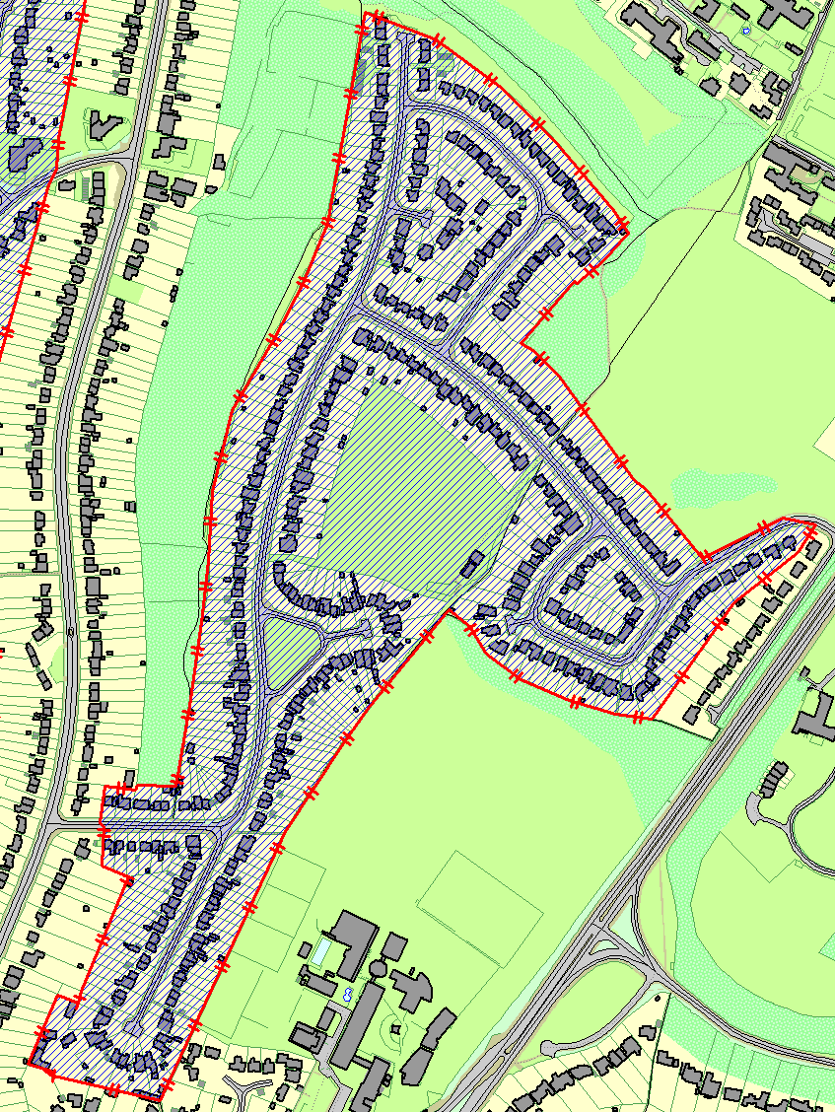
The plan below shows the proposal of the whole area within the red boundary that falls under Poets Corner. The roads that fall within the area are the following: Carver Hill Road, Ellsworth Road, Keats Close, Kingsley Crescent, Shelley Road and Wordsworth Road.

