18th October 2022

Ref: Lakes Lane, Beaconsfield Parking Restrictions

Dear Sir/Madam,

Dear Resident,

Subject: Proposed Resident Parking Permit Zone Scheme- Lakes Lane, Beaconsfield- Informal Consultation
Buckinghamshire County Council in partnership with Transport for Bucks is working with your County Councillor, and Parish Councillors, who are considering Resident Parking Permits (RPP) which could potentially improve parking for residents, on Lakes Lane, Beaconsfield.
We are seeking residents’ views on whether they would support or object to the principle of having an RPP scheme on their road to deal with inappropriate parking and improve road safety, accessibility and efficiency.
There are advantages and disadvantages which you should consider when making your decision on whether you would support a RPP scheme. These are as follows:
Advantages:
- Residents having no off-street parking facility would have a reasonable opportunity to park close to their homes. Resident parking schemes do not offer any guarantees of a parking space and certainly not a parking space in front of the resident’s own home.
- The amenity of the area would be improved with vehicles being parked in a more orderly fashion.
- A scheme may have benefits from a social, community safety, housing or planning policy aspect.
- A scheme can encourage the use of alternative modes of transport.
- They may reduce traffic flows on residential streets.
- The reduction in the number of vehicles driving around an area searching for a parking place can improve local air quality.
- A scheme can improve road safety by reducing the number of vehicles using an area and also the number parked in unsuitable locations.
Disadvantages:
- Schemes do not agree with the primary role of the highway which is to ensure passage and re-passage.
- A resident parking scheme in one area might create or worsen parking problems in adjacent areas.
- Parking capacity for residents could at times be inadequate.
- A scheme may limit the residents’ freedom to keep unlimited numbers of taxed vehicles on street (current limit is 3 vehicles per property).
- Permits to park in the area are charged to the residents within the zone area (current prices are 1st resident permit £55, 2nd resident £70 and 3rd resident permit is £90 per year, visitor permits are limited to 200 per property in a 12 month period at a cost of £12 per 10 off).
- All on-street parking within the road during restricted times will require a valid permit to be linked to the vehicle.

What can you do?
Below in this letter, a plan is attached which shows the section of road for which the restriction is proposed. A link to an online survey is https://yourvoicebucks.citizenspace.com/roads-parking/lakes-lane-informal-consultation, where you can submit your responses to have your say. please complete it by Tuesday 8th November 2022. Alternatively, you can email or write to us at the address at the top of this letter with your comments.
Under the Local Government (Access to Information) Act 1985 we are obliged to make any representations received in response to this notice, open to public inspection, however we will remove personal information such as your name or address.
What happens next?
The final proposals that result from these wider public views will then need to go through a statutory legal consultation period before any work can be implemented. Assuming all goes to plan, and there is the necessary support from residents.
PROPOSED PLAN
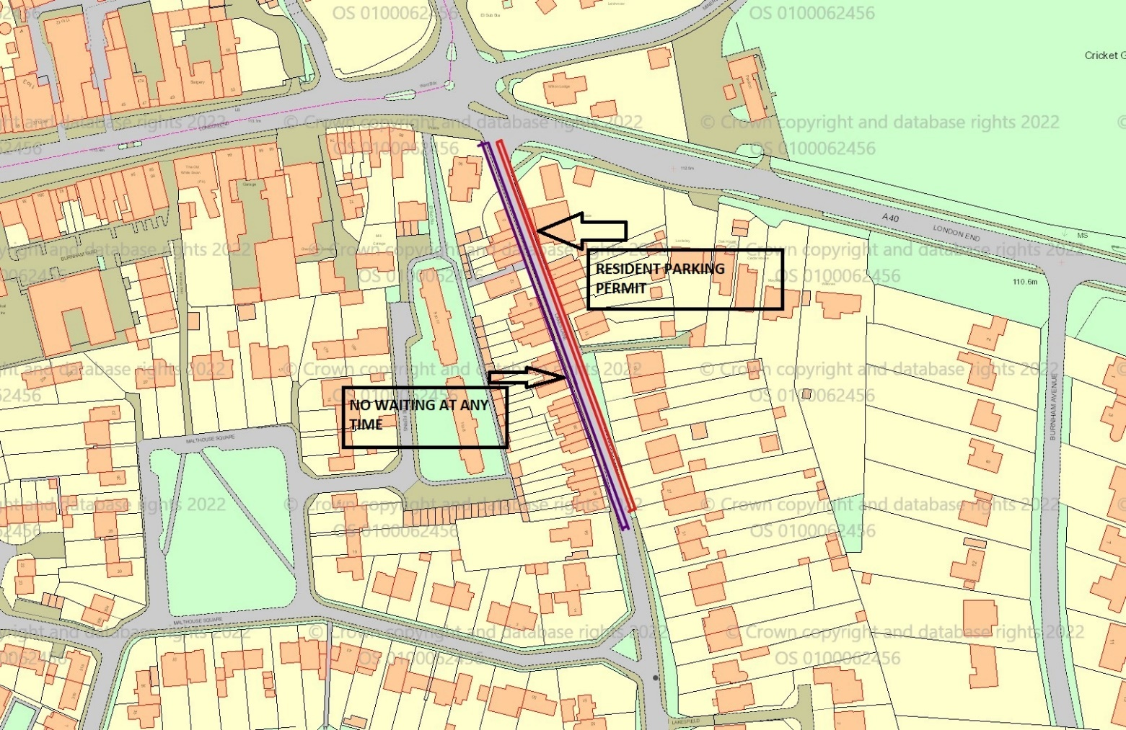

Yours sincerely,
Ujjwal kakkar
Graduate Engineer

