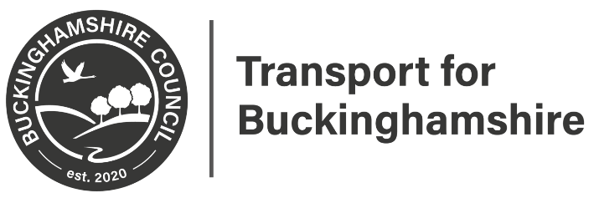
Directorate for Communities
Contract Director: Andrew Sellors
Transport for Buckinghamshire
Aylesbury Vale Area Office
Corrib Industrial Park, Griffin Lane
Aylesbury
HP19 8BP
01296 382416
www.buckinghamshire.gov.uk

August 2022

Dear Sir or Madam

Parking Review Wendover, Flackwell Heath and Marlow – Formal Consultation

We are working with your Parish/Town Council and Community Board to improve the parking situation for residents. The intention is to create a safer environment by putting in some more double yellow lines and mark out areas where it is safe to park.

What can you do?

If you would like to comment on the proposals or view the plan, please visit the Your Voice Bucks website at www.yourvoicebucks.citizenspace.com/ and look for “Wendover, Flackwell Heath and Marlow Parking Review” where you will find a link to an online survey, please complete it by the 16th September 2022.

Alternatively, you can email us at: parkingtro@buckinghamshire.gov.uk or write to us at the address at the top of this letter with your comments. If you do not have access to the internet, you can find a copy of this letter and copies of all the plans at The Gateway, Gatehouse Rd, Aylesbury HP19 8FF during opening hours.

Under the Local Government (Access to Information) Act 1985 we are obliged to make any representations received in response to this notice, open to public inspection, however we will remove personal information such as your name or address.

What happens next?

Once the Formal consultation has finished, all responses will be considered, and the plan will be amended accordingly (if necessary). We will then formally advertise the making of the Amendment Order, based on the outcome of the Formal Consultation. All going well we hope to implement the lines by early 2023. This web page www.yourvoicebucks.citizenspace.com/ will keep you updated about the outcome of the statutory consultation.

Yours faithfully
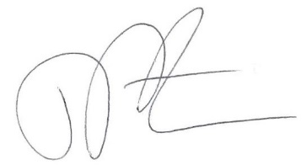
John Pateman
Design Services Team Leader, Transport for Buckinghamshire
01296 382416

