Transport for Buckinghamshire  Contract Director  Louise McCann | Buckinghamshire County Council  Transport. Economy. Environment  Aylesbury Vale Area Office  Corrib Industrial Park,  Griffin Lane, Aylesbury  Buckinghamshire  HP19 8BP  Telephone 0845 2302882  Email parkingtro@buckscc.gov.uk  Fax 0845 2938044  www.buckscc.gov.uk  Date: 10 March 2021  Ref: TR/Wendover Parking Review
Dear Resident,

Subject: Proposed Parking Controls in Wendover
Buckinghamshire Council in partnership with Transport for Bucks is working with your Ward Councillors, Parish Councillors and residents in Wendover. We have undertaken a review and made recommendations on a number of different parking controls to address parking needs in Wendover.
Your views are sought on these proposals, as they are located close to your property.
Plans indicating the changes and further information can be viewed at the following locations:
- Bucks County Council “Your Voice” Webpage - https://yourvoicebucks.citizenspace.com/roads-parking/wendover-parking-review-informal/

The plans include map tiles showing the proposals in more detail.

What can you do?
Plans of the proposals can be viewed online at https://yourvoicebucks.citizenspace.com/roads-parking/wendover-parking-review-informal/ A link to an online survey can be found here, please complete it by the Tuesday 30th March 2021. Alternatively, you can email or write to us at the address at the top of this letter with your comments.
What happens next?
The final proposals that result from these wider public views will then need to go through a statutory legal consultation period before any work can be implemented. Assuming all goes to plan, and there is the necessary support from residents, the road line work should be implemented towards the end of 2021.
Below is a helpful guide to locate which map tile you will need to look at to find your road online.

Roads with an element of highway code/safety parking controls |  | Map Tile Number
Bryants Acre, Wendover | Double yellow lines on the bends of the road | EP59, EQ59
Clay Lane, Wendover | Double yellow lines on the junction | ER60
Grange Gardens, Wendover | Single yellow lines | ER59
Manor Road, Wendover | Double yellow lines on the junctions | ER60
Swan Mews, Wendover | Double yellow lines on the junction | ER59
The Paddocks, Wendover | Double yellow lines on the junction | ER59
Tring Road, Wendover | Double yellow lines | ER60, ES59, ES60
Wharf Road, Wendover | Double yellow lines on the junction | ER59

Roads with single yellow lines |  | Map Tile Number
Perry Street, Wendover | Single yellow lines | EQ59, ER58

Roads with complex or a number of proposals/options |  | Map Tile Number
Chiltern Road, Wendover | Sections of double yellow lines and resident permit holders only. | ER58, ER59
Little Hampden Close, Wendover | Sections of double yellow lines and resident permit holders only. | ET59
South Street, Wendover | Sections of resident permit holders only. | ET59
Vicarage Road, Wendover | Sections of resident permit holders only. | ER58, ER59
Vinetrees, Wendover | Sections of single yellow lines, disabled badge holders only and resident permit holders only. | ES59

Yours sincerely,
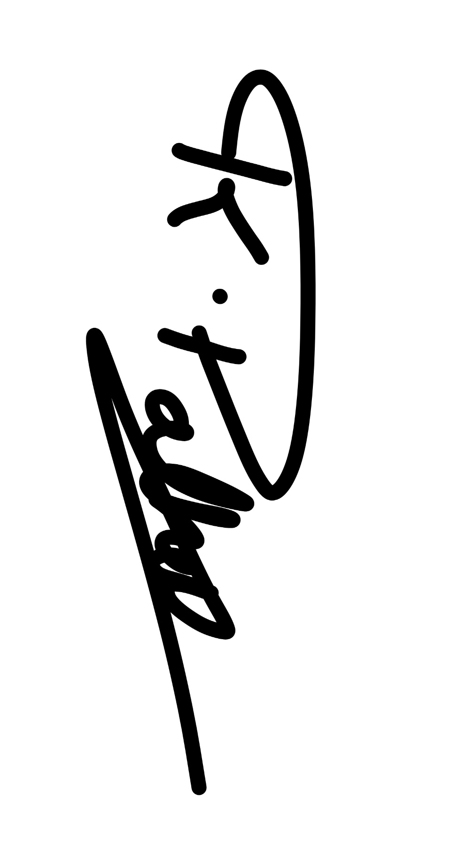

Karishma Pathak
Apprentice Technician | Network Improvement Team | Design Delivery
Transport for Buckinghamshire

