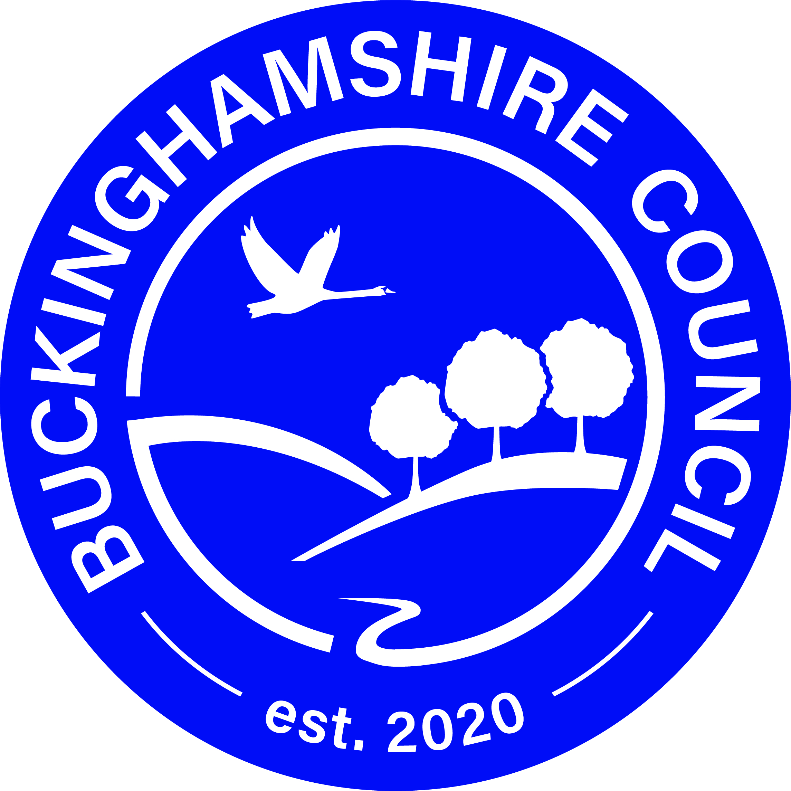

Buckinghamshire Council Consultation

Home to School Transport Policy &

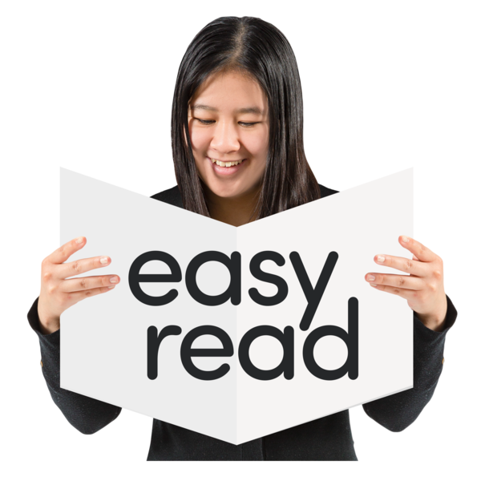
Post-16 Transport Statement 2021/22

What is the Home to School Transport Policy?

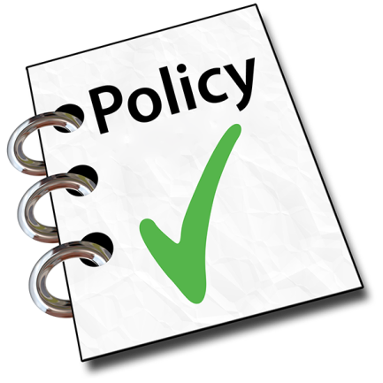
The Council has lots of policies they tell you how we will do things.
Home to School Transport Policy
This policy says how we will provide transport to schools and other educational settings.
The Policy helps make sure pupils arrive at school or other setting ready to learn.

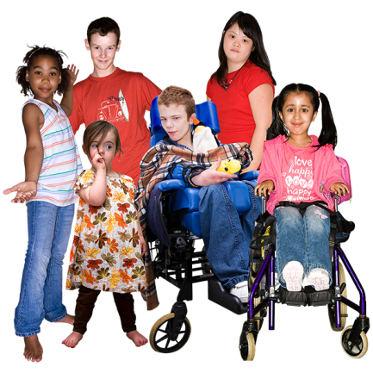
The policy covers pupils from 0 – 19 years old.
For people with Special Educational Needs and Disabilities it goes up 25 years.

What is the Post 16 Transport Policy Statement?
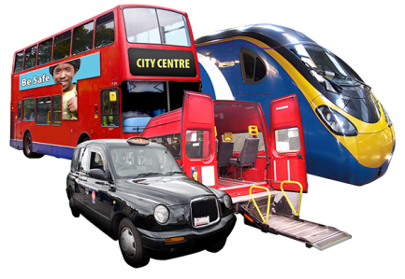
The Council has to agree what transport sixth form students need.
This is so that we can help them attend education or training.
We call this the Post 16 Transport Policy Statement. It is for students aged 16 and over living in Buckinghamshire

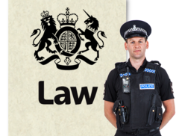
The law says the Council must publish the statement for you to see.
So everyone knows what travel and transport plans are in place for young people.

Why we want your views
We looked at the Home to School Transport Policy last year.
This was to see if we needed to make any changes.
We decided to make some changes to it in March 2019.
These changes started in September 2019.
We look at the Post 16 Transport Policy Statement every year. We asked for your views on it in July 2020.
The current Statement says there will be charges for 16–18 year old students with SEND who get transport.
This school year nobody was charged. This was a very special decision made because of COVID-19.
Charges will start again in September 2021.
We are now looking again at our Home to School Transport Policy and Post-16 Transport Policy Statement.
As part of this we are thinking about making some changes. If we made any changes they would start in March 2021.
We have looked at feedback from parents and schools.

We have also spoken with some parents about what changes they would like to see.

We now want to know what you think.

What are the proposed changes?

Home to School Transport Policy

There are no big changes planned. We are planning to update the content of the Policy. We want to make it easier to understand. So that students and families can choose the best school transport for their needs.

Post 16 Transport Policy Statement
We are planning to update the content of the Policy Statement. We want to give clear information for young people, parents or carers.
Charging for Post 16 transport will continue from September 2021. So we are asking for views on how transport will be paid for and arranged for students aged 16–19 with SEND. There are three options to look at.
Some of the proposed changes might apply to you.

What we are asking you
We would like you to think about:
- the changes we want to make
- the charging options for Post 16 transport

We would like you to tell us:
- if you find the changes easy to understand
- what is important to you
- what other comments you have

How can I tell you what I think?
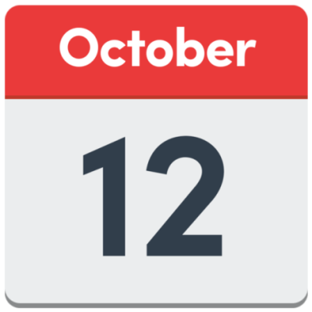
The consultation starts on 12 October.
It will end on 7 December 2020.

You can get more information online.

Just go to the Your Voice Bucks website.

You can tell us what you think by completing a short survey.
You can do this online by going to Your Voice Bucks

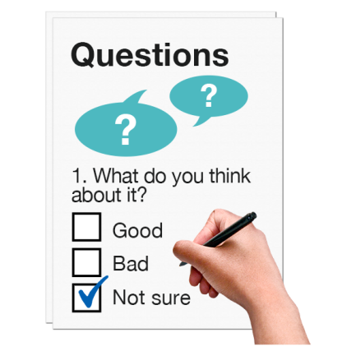
You can also fill in a paper version. There is one at the end of this Easy Read document.
You will need to post this to us or drop it off at one of the council buildings.

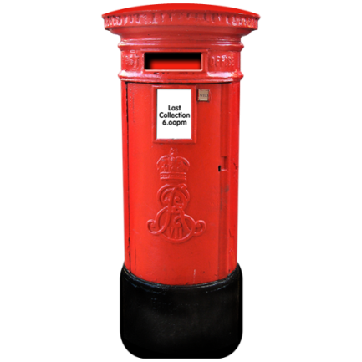
Post your paper survey to Helen Fincher at:
Home to School Transport Policy Consultation
Buckinghamshire Council
Walton Street Offices
Aylesbury, HP20 1UZ.

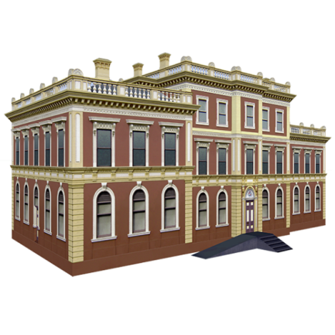
You can drop off paper copies at one of these council buildings:
- The Gateway, Gatehouse Road, Aylesbury
- Walton Street Offices, Aylesbury
- Queen Victoria Road, High Wycombe
- King George V House, King George V Road, Amersham
These are council access points. You can find access point addresses here
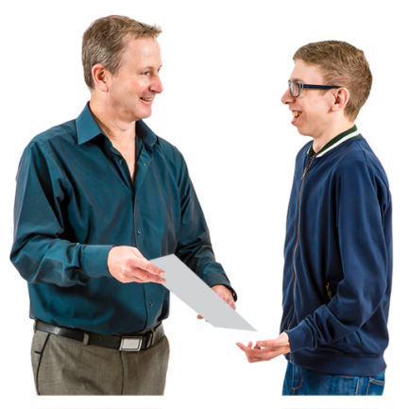
You may want help to complete the survey.
Ask someone you trust to help - like a parent or teacher.
They can explain what everything means and help you fill in the survey.
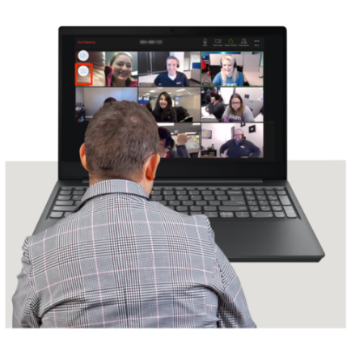
You can also join one of our virtual discussion groups.
Parents and carers can join a group too. You will be able to ask questions and tell us what you think.
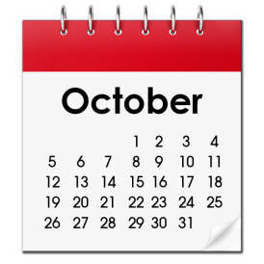
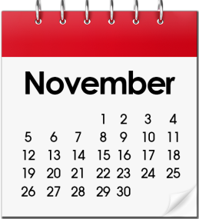
The groups will be in October and November. If you would like to take part email us at H2ST policy consultation.

Full details of the discussion groups are on here on Your Voice Bucks.

Data protection
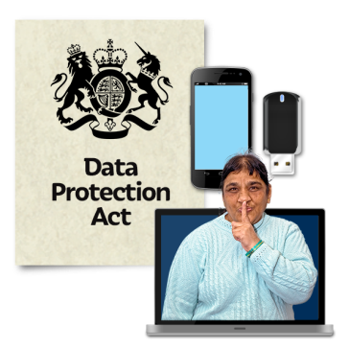
We will keep your information safe.
What you tell us is confidential.
We will only use what you say to help with our work on home to school transport.

What happens next?
To find out what happens after the consultation has ended got to Your Voice Buck (opens in a new window)
This is where we will put any news or decisions. Thank you for time and giving us your views.
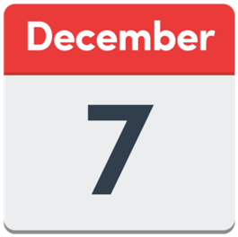
The survey ends Monday 7 December 2020.

FOLLOW THIS TEXT WITH THE CONSULTATION QUESTIONS – TBC when finalised.

